SkinMedica Product Website Guide
for The Elixir Vanity by Velaisance
This guide covers the eight SkinMedica products in your uploaded Product List, corrected to Retinol Complex 0.5 as you confirmed. Neck Correct Cream is included as a separate reference entry because you supplied its image, but inventory is unconfirmed. Product names and older packaging were compared with your spa photo, uploaded images, manufacturer materials, and retailer listings on October 31, 2026.

Catalog and packaging matches
Product | Internal SKU | Retail USD
Instant Bright Eye Cream | EV-SM-IBE-01 | $92.00
Retinol Complex 0.5 | EV-SM-R05-01 | $84.00
TNS Advanced+ Serum | EV-SM-TNS-01 | $295.00
Even & Correct Advanced Brightening Treatment | EV-SM-ECB-01 | $178.00
Essential Defense Mineral Shield Broad Spectrum SPF 35 | EV-SM-MS35-01 | $40.00
HA5 Hydra Collagen Hydrating Foaming Cleanser | EV-SM-HFC-01 | $48.00
HA5 Hydra Collagen Replenish + Restore Hydrator | EV-SM-HHR-01 | $192.00
Dermal Repair Cream | EV-SM-DRC-01 | $134.00

Instant Bright Eye Cream
Internal SKU EV-SM-IBE-01
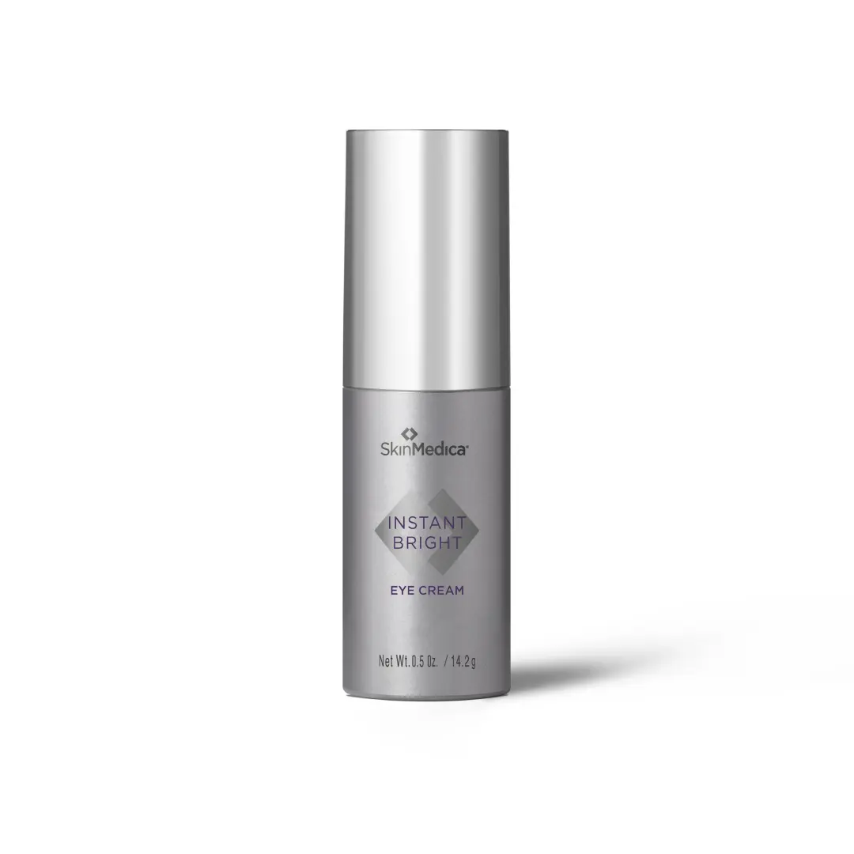
Category Eye Care
Reference retail price $92.00 USD
Size 0.5 oz / 14.2 g on legacy image; verify carton
Packaging match Legacy silver packaging matches the visible Instant Bright carton. Your list gives 15 mL; the legacy image states net weight 0.5 oz / 14.2 g. Verify actual carton units.

Website description
Hydrate and refresh the look of tired eyes. This targeted eye cream helps improve the appearance of dark circles, puffiness, and fine lines for a smoother, brighter-looking eye area.
Featured ingredients Phenylethyl resorcinol, marine extracts, hyaluronic acid
How to use Apply a thin layer twice daily beneath and adjacent to eyes and on eyelids, avoiding contact with eyes. Rinse thoroughly if contact occurs.
Suggested URL /elixir-vanity/skinmedica-ibe
SEO title Instant Bright Eye Cream | The Elixir Vanity
Meta description Shop SkinMedica Instant Bright Eye Cream at The Elixir Vanity by Velaisance. Explore this product.
Image and alt text skinmedica-ibe-legacy.png | SkinMedica silver Instant Bright Eye Cream bottle.
Source https://evolvemedspa.com/shop/

Retinol Complex 0.5
Internal SKU EV-SM-R05-01
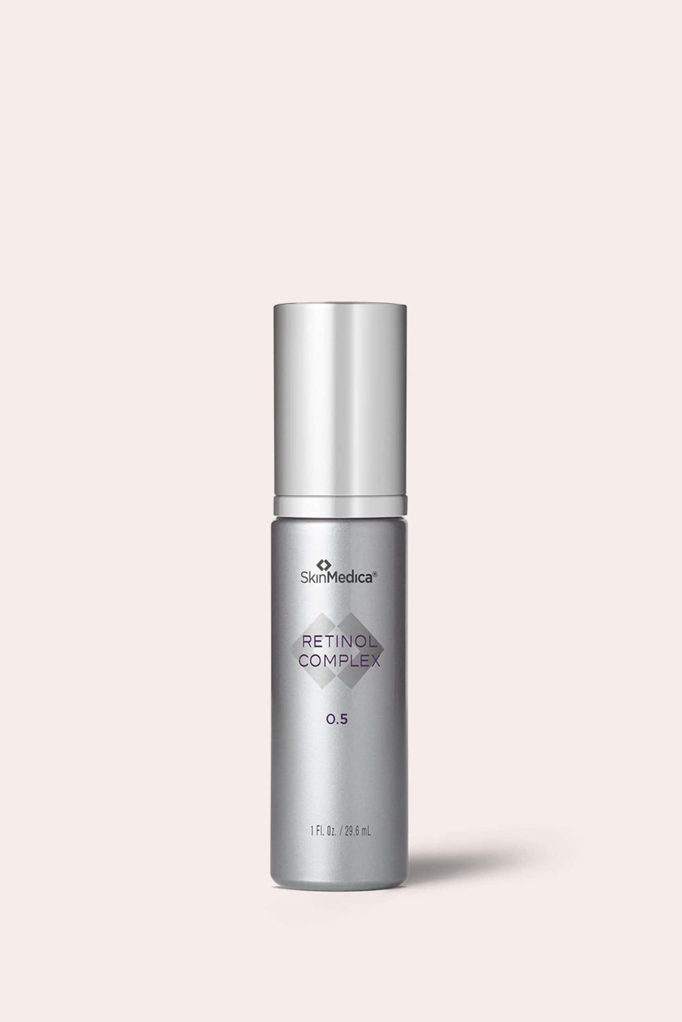
Category Retinol Treatments
Reference retail price $84.00 USD
Size 1 fl oz / 29.6 mL on uploaded image
Packaging match Strength confirmed by you on October 31, 2026. Uploaded 0.5 photo is correct; the 1.0 entry in your source list is superseded.

Website description
Refine your evening routine with Retinol Complex 0.5. Designed for retinoid-conditioned skin, this treatment helps soften the appearance of fine lines and uneven texture while supporting a smoother-looking complexion.
Featured ingredients Retinol, niacinamide, antioxidant PhytoShield complex
How to use Apply one pump to the face in the evening after cleansing, before moisturizer. Avoid eyes. Begin with limited frequency and increase as tolerated according to the package and your provider.
Caution Do not use while pregnant, breastfeeding, or planning pregnancy. Redness, peeling, and irritation can occur. Use daily SPF 30 or higher and limit sun exposure during use and for one week after stopping.
Suggested URL /elixir-vanity/skinmedica-r05
SEO title Retinol Complex 0.5 | The Elixir Vanity
Meta description Shop SkinMedica Retinol Complex 0.5 at The Elixir Vanity by Velaisance. Explore this product.
Image and alt text skinmedica-r05-legacy.png | SkinMedica Retinol Complex 0.5 silver bottle.
Source https://store.skinmds.com/skinmedica-retinol-complex-0-5

TNS Advanced+ Serum
Internal SKU EV-SM-TNS-01
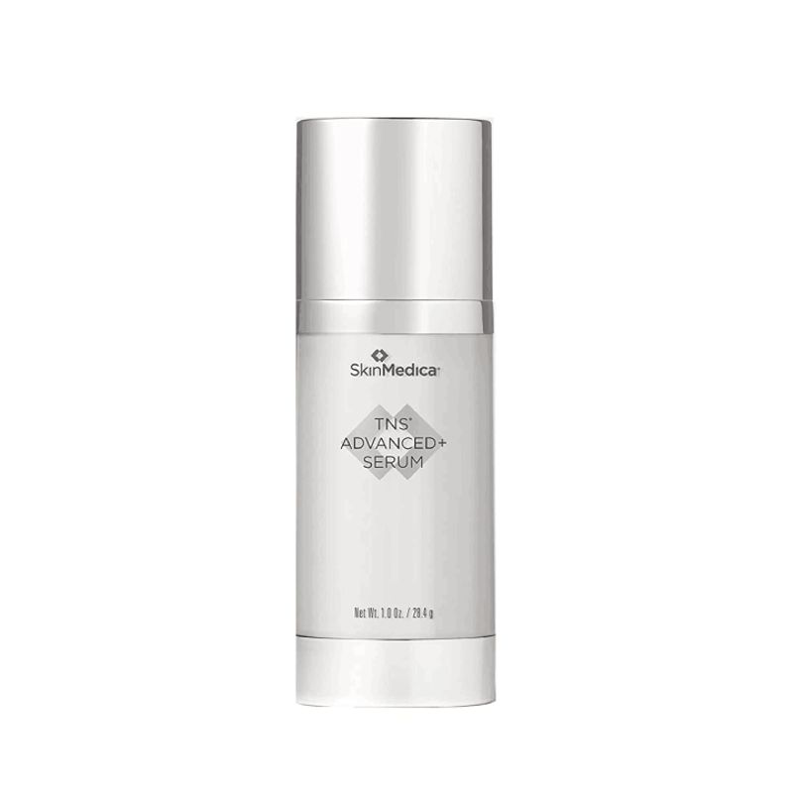
Category Serums
Reference retail price $295.00 USD
Size Net wt 1 oz / 28.4 g on uploaded legacy image
Packaging match Name and carton design match your spa photo. The two uploaded TNS photos depict the same product; use the clean white-background image as the main listing image.

Website description
Elevate your daily skincare with a dual-formula serum featuring growth factors, peptides, and supporting ingredients. TNS Advanced+ Serum helps improve the appearance of fine lines, wrinkles, uneven tone, and texture.
Featured ingredients TNS-MR growth factor blend, peptides, RENESSENSCE Advanced blend
How to use Use morning and evening after cleansing and toning. Dispense both formulas onto the back of your hand, blend, and apply to clean, dry face; neck and chest if desired. Allow absorption before other products. Avoid eyes.
Suggested URL /elixir-vanity/skinmedica-tns
SEO title TNS Advanced+ Serum | The Elixir Vanity
Meta description Shop SkinMedica TNS Advanced+ Serum at The Elixir Vanity by Velaisance. Explore this product.
Image and alt text skinmedica-tns-legacy.png | SkinMedica TNS Advanced+ Serum legacy silver and white bottle.
Source https://evolvemedspa.com/shop/

Even & Correct Advanced Brightening Treatment
Internal SKU EV-SM-ECB-01
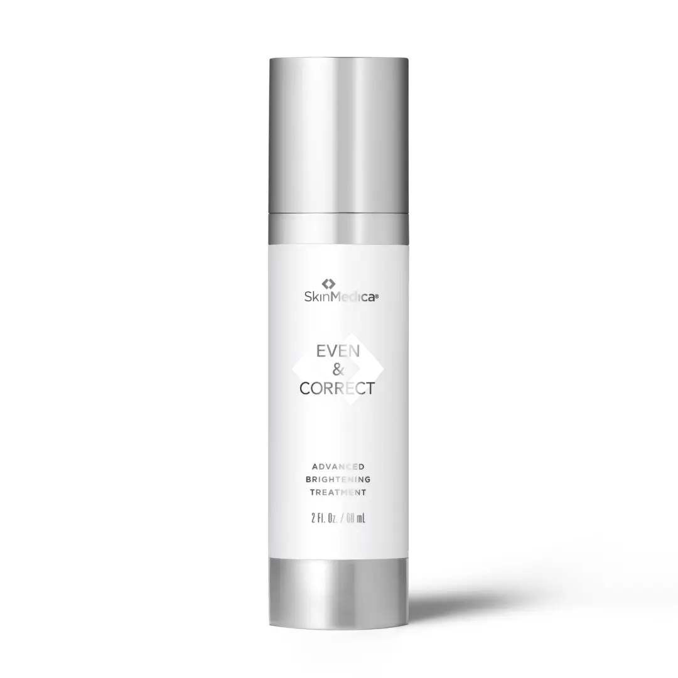
Category Brightening Treatments
Reference retail price $178.00 USD
Size 2 fl oz / 60 mL on legacy image and spa carton
Packaging match Legacy 2 fl oz image matches the carton visible in your spa photo. Your source list shows 50 mL; use your carton size instead after a close-up check. Do not substitute Dark Spot Cream or Treatment Pads.

Website description
Support a more even-looking complexion with this daily brightening serum. The formula targets the appearance of dark spots and uneven tone, with a hydroquinone-free and retinol-free approach to visible discoloration.
Featured ingredients Tranexamic acid, niacinamide, lotus sprout extract, phenylethyl resorcinol
How to use Smooth over face, neck, and chest morning and evening after cleansing and toning. Avoid eyes. Use SPF 30 or higher during sun exposure.
Suggested URL /elixir-vanity/skinmedica-ecb
SEO title Even & Correct Advanced Brightening Treatment | The Elixir Vanity
Meta description Shop SkinMedica Even & Correct Advanced Brightening Treatment at The Elixir Vanity by Velaisance. Explore this product.
Image and alt text skinmedica-ecb-legacy.png | SkinMedica Even and Correct Advanced Brightening Treatment silver 2 fl oz bottle.
Source https://evolvemedspa.com/shop/

Essential Defense Mineral Shield Broad Spectrum SPF 35
Internal SKU EV-SM-MS35-01
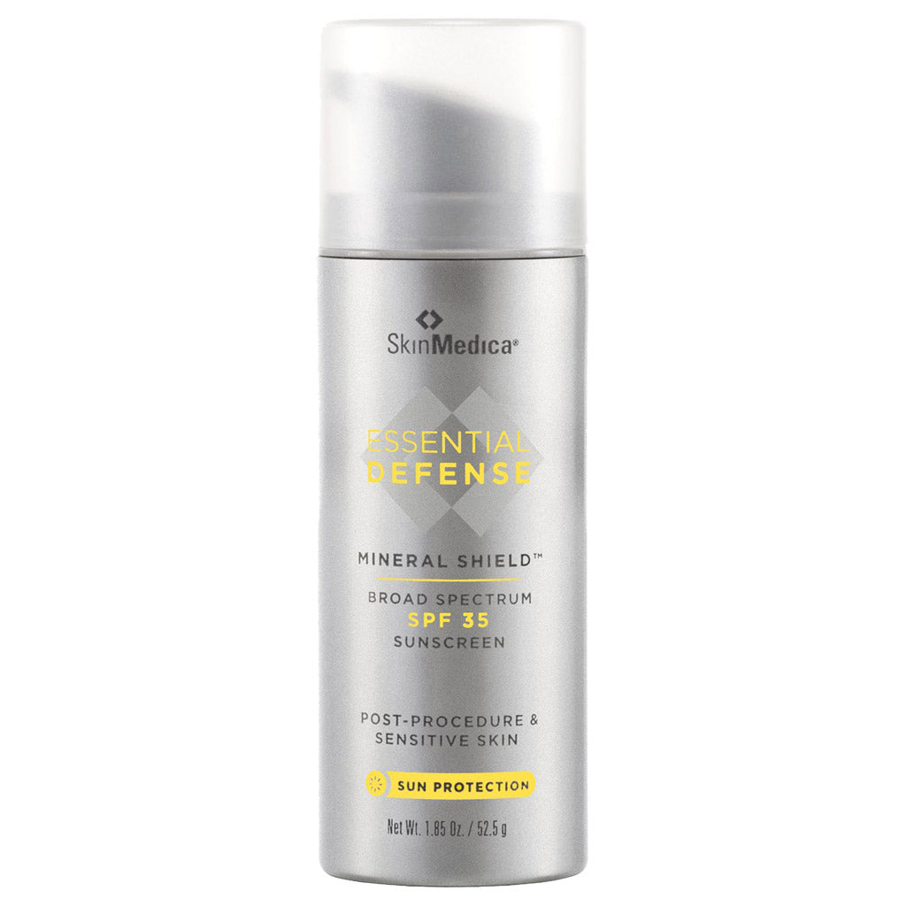
Category Sun Care
Reference retail price $40.00 USD
Size Legacy image net wt 1.85 oz / 52.5 g; verify your box
Packaging match Essential Defense is visible in the spa photo, but the SPF and subtype are obscured. Your product list identifies untinted SPF 35. Verify box before activating; do not substitute tinted SPF 32 or Everyday Clear SPF 47.

Website description
Finish your morning routine with a lightweight mineral sunscreen offering broad-spectrum SPF 35 protection. This untinted Mineral Shield formula combines zinc oxide and titanium dioxide for daily sun protection.
Featured ingredients Titanium dioxide 5%; zinc oxide 6%
How to use Apply generously 15 minutes before sun exposure. Reapply at least every two hours. Use a water-resistant sunscreen for swimming or sweating. Children under six months: ask a doctor.
Warnings External use only. Do not use on damaged or broken skin. Keep out of eyes; rinse with water. Stop use and ask a doctor if rash occurs. Keep out of reach of children. If swallowed, seek medical help or contact Poison Control. Use shade and protective clothing; limit midday sun. Do not claim water resistance.
Suggested URL /elixir-vanity/skinmedica-ms35
SEO title Essential Defense Mineral Shield Broad Spectrum SPF 35 | The Elixir Vanity
Meta description Shop SkinMedica Essential Defense Mineral Shield Broad Spectrum SPF 35 at The Elixir Vanity by Velaisance. Explore this product.
Image and alt text skinmedica-ms35-legacy.png | SkinMedica Essential Defense Mineral Shield SPF 35 legacy silver pump bottle.
Source https://www.skinmedica.com/us/product-category/sunscreens/20087377.html

HA5 Hydra Collagen Hydrating Foaming Cleanser
Internal SKU EV-SM-HFC-01
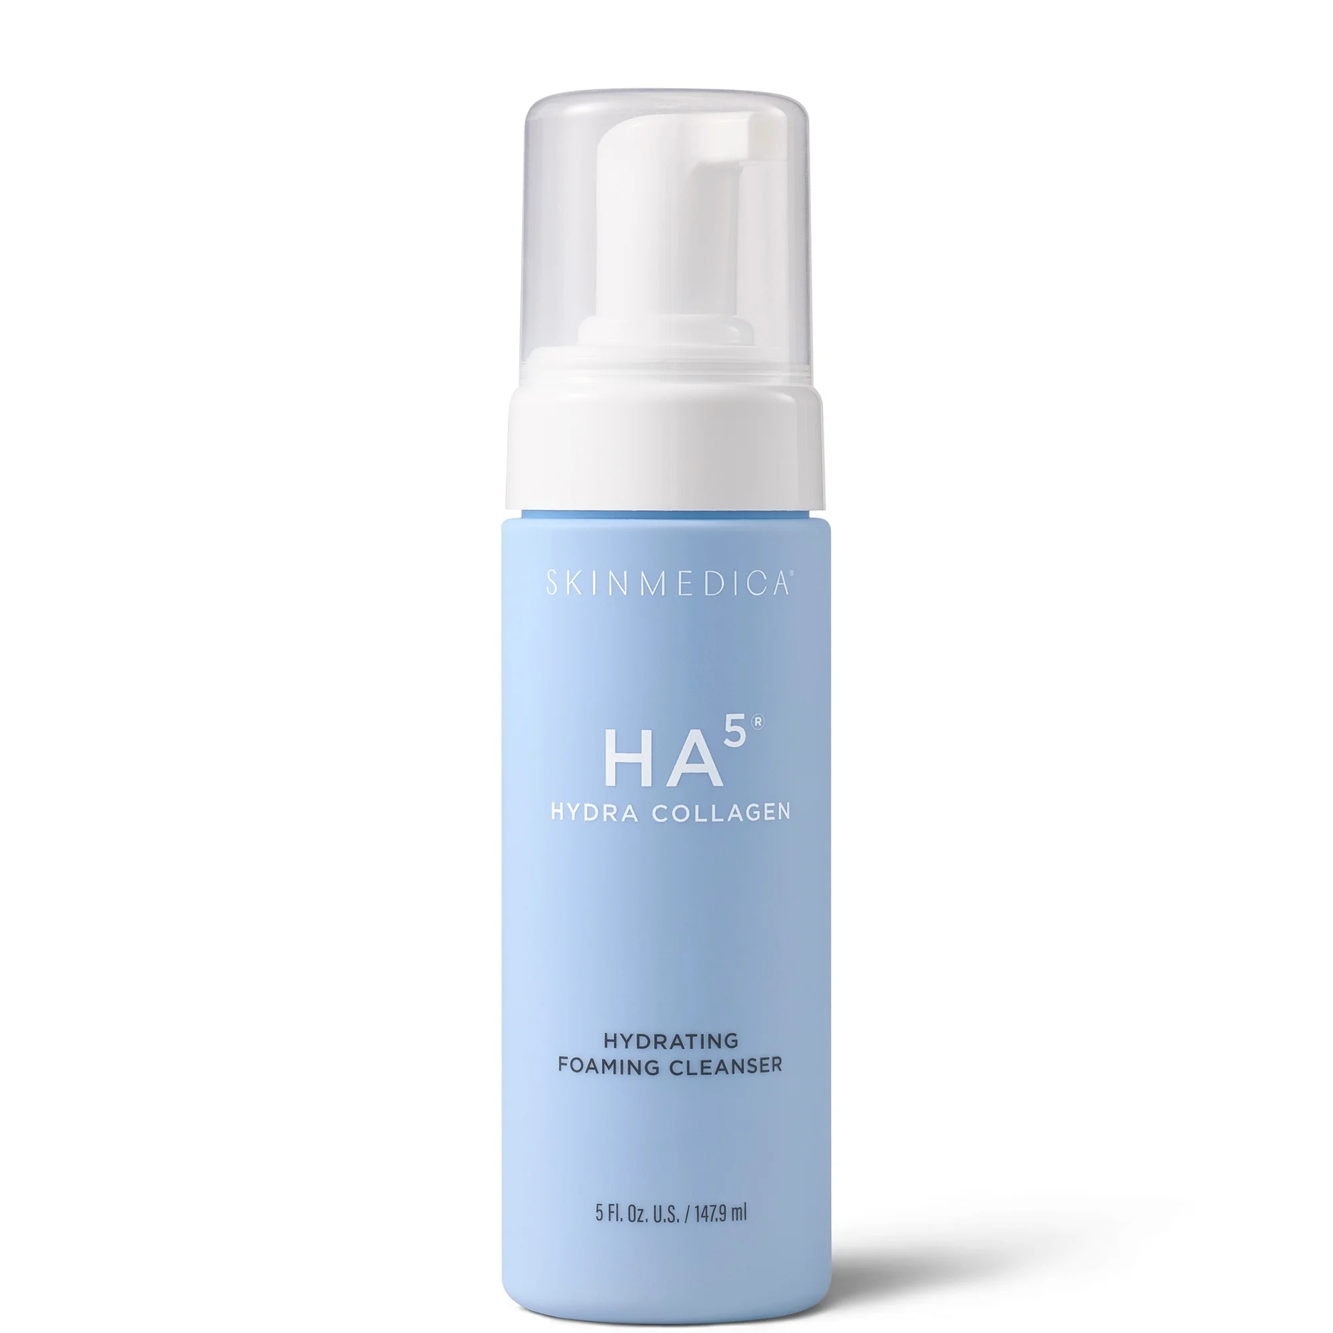
Category Cleansers
Reference retail price $48.00 USD
Size 5 fl oz / 147.9 mL on supplied image
Packaging match Supplied image shows the correct cleanser identity, not the hydrator. The blue left-hand spa carton is partly obscured; verify lower front label before confirming this as the shelf item.

Website description
Start your routine with a gentle, foaming cleanse. Amino acid-based cleansing ingredients and the HA5 Hydra Collagen complex help remove makeup, oil, and daily impurities while leaving skin feeling soft and hydrated.
Featured ingredients Amino acid-based surfactants, five forms of hyaluronic acid, collagen, pea peptides
How to use Morning and evening, moisten face with warm water. Massage 1–2 pumps over skin in circular motions, rinse thoroughly, and pat dry. Avoid eyes.
Suggested URL /elixir-vanity/skinmedica-hfc
SEO title HA5 Hydra Collagen Hydrating Foaming Cleanser | The Elixir Vanity
Meta description Shop SkinMedica HA5 Hydra Collagen Hydrating Foaming Cleanser at The Elixir Vanity by Velaisance. Explore this product.
Image and alt text skinmedica-hfc-legacy.png | SkinMedica HA5 Hydra Collagen blue foaming cleanser bottle with clear pump cap.
Source https://www.prnewswire.com/news-releases/skinmedica-unveils-its-newest-hydration-hero-302532827.html

HA5 Hydra Collagen Replenish + Restore Hydrator
Internal SKU EV-SM-HHR-01
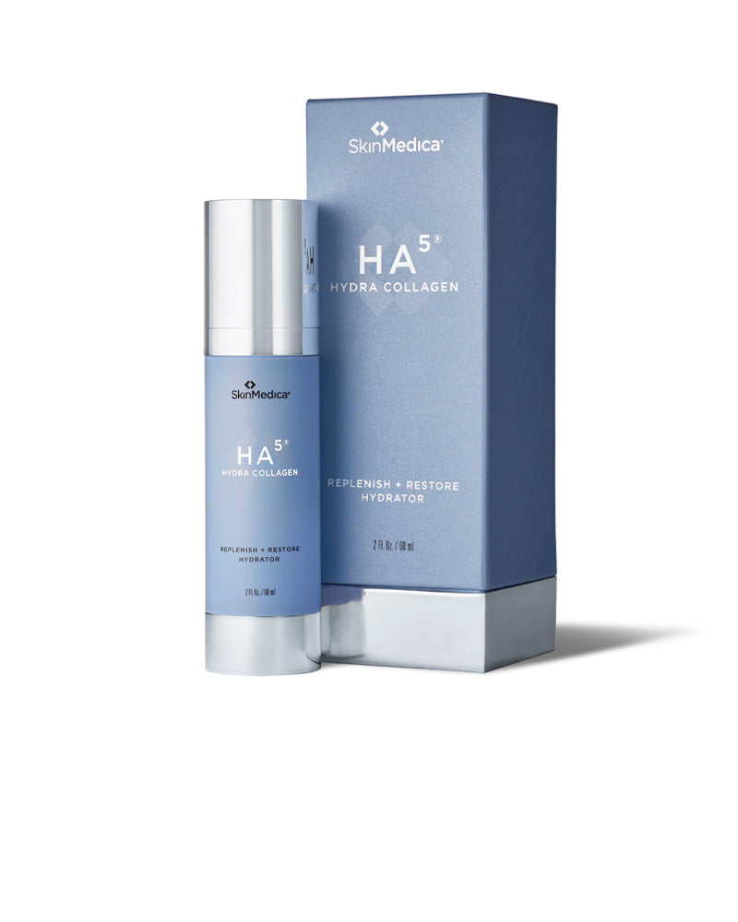
Category Hydrators
Reference retail price $192.00 USD
Size 2 fl oz / 60 mL on blue legacy carton
Packaging match Blue Replenish + Restore carton is clearly visible at your spa. Selected image matches the legacy 2 fl oz package; do not use the original silver HA5 Rejuvenating Hydrator or current 50 mL package image.

Website description
Give dry-feeling skin a replenishing layer of moisture. This lightweight hydrator combines a blend of hyaluronic acids with Hydra Collagen technology to help skin look smoother, plumper, and dewy.
Featured ingredients Hyaluronic acid blend, Hydra Collagen complex, VITISENSCE technology
How to use Use 1–2 pumps morning and evening on face, neck, and chest after cleansing and treatment products, before moisturizer and daytime SPF. Avoid eyes.
Suggested URL /elixir-vanity/skinmedica-hhr
SEO title HA5 Hydra Collagen Replenish + Restore Hydrator | The Elixir Vanity
Meta description Shop SkinMedica HA5 Hydra Collagen Replenish + Restore Hydrator at The Elixir Vanity by Velaisance. Explore this product.
Image and alt text skinmedica-hhr-legacy.png | SkinMedica HA5 Hydra Collagen blue hydrator bottle and 2 fl oz carton.
Source https://shop.rendermatology.com/products/skinmedica-ha-%C2%AE-hydra-collagen-replenish-restore-hydrator

Dermal Repair Cream
Internal SKU EV-SM-DRC-01
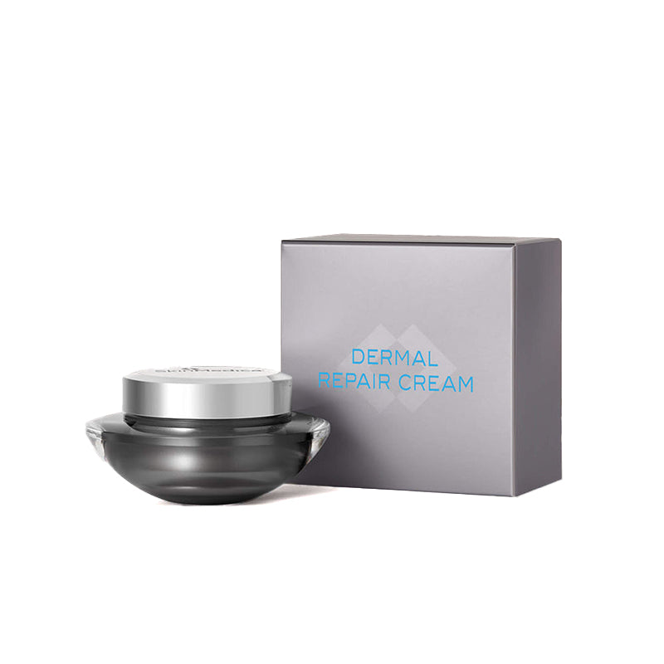
Category Moisturizers
Reference retail price $134.00 USD
Size Verify legacy jar label; source list states 50 mL / 1.7 fl oz
Packaging match Gray Dermal Repair Cream carton matches your spa photo. Selected image preserves that packaging generation. Confirm your jar size because legacy weight and current volume labels can differ.

Website description
Comfort dry-feeling skin with a rich moisturizer that helps replenish moisture and soften the look of rough texture. Antioxidant vitamins and hyaluronic acid support a smooth, nourished-looking finish.
Featured ingredients Vitamin C derivative, vitamin E, sodium hyaluronate
How to use Twice daily after cleansing and treatment products, use a spatula to apply a dime-sized amount over face; neck and chest if desired. Avoid eyes.
Suggested URL /elixir-vanity/skinmedica-drc
SEO title Dermal Repair Cream | The Elixir Vanity
Meta description Shop SkinMedica Dermal Repair Cream at The Elixir Vanity by Velaisance. Explore this product.
Image and alt text skinmedica-drc-legacy.png | SkinMedica Dermal Repair Cream legacy silver jar and gray carton.
Source https://regimenpro.com/products/dermal-repair-cream

Ingredient reference lists
These lists are provided for website setup and label comparison. The uploaded Product List is the source for entries other than Retinol 0.5 and Neck Correct. Publish only after comparing with your actual carton; current and legacy formulas may be labeled differently. Ingredients are not proof of a packaging match.

Instant Bright Eye Cream
Aqua/Water/Eau, Dimethicone, Glycerin, Butylene Glycol, HDI/Trimethylol Hexyllactone Crosspolymer, Polysilicone-11, Ethylhexyl Olivate, Boron Nitride, Sodium Acrylate/Sodium Acryloyldimethyl Taurate Copolymer, Phenylethyl Resorcinol, Polymethylsilsesquioxane, Phenoxyethanol, Albizia Julibrissin Bark Extract, Decyl Glucoside, Caﬀeine, Isohexadecane, Vitis Vinifera (Grape) Flower Cell Extract, Hydroxyacetophenone, Trehalose, Urea, Pentylene Glycol, Polysorbate 80, Sucrose Palmitate, Maris Aqua/Sea Water/Eau de mer, Caprylyl Glycol, Sclareolide, Disodium EDTA, Tromethamine, Diethylhexyl Syringylidenemalonate, Ethylhexylglycerin, Squalane, Tocopheryl Acetate, Polysorbate 60, Silica, Serine, Lecithin, Xanthophylls, Propanediol, Sodium Hyaluronate, Alteromonas Ferment Extract, Sodium Hyaluronate Crosspolymer, Sodium Chloride, Pullulan, Disodium Phosphate, Algin, Glyceryl Polyacrylate, Hydrolyzed Hyaluronic Acid, Caprylic/Capric Triglyceride, Porphyridium Cruentum Extract, Potassium Sorbate, Potassium Phosphate, Sigesbeckia Orientalis Extract, Citric Acid, Tocopherol, Hydrolyzed Yeast Extract, Glycolipids

Retinol Complex 0.5
Water/Aqua/Eau, Cetyl Ethylhexanoate, Glycine Soja (Soybean) Oil, Niacinamide, Polyacrylate-13, Caprylic/Capric Triglyceride, Squalane, Retinol, Palmitoyl Tripeptide-8, Dunaliella Salina Extract, Magnolia Grandiflora Bark Extract, Tocopherol, Tocotrienols, Ceramide 3, Bisabolol, Phytosterols, Squalene, Tocopheryl Acetate, Oryza Sativa (Rice) Bran Wax (Oryza Sativa Cera), Glycerin, Polysorbate 20, Butylene Glycol, Cetyl Palmitate, Laureth-23, Trideceth-6 Phosphate, Sodium Hydroxide, Dicaprylyl Ether, Lauryl Alcohol, Polyisobutene, Dextran, Potassium Sorbate, Disodium EDTA, Phenoxyethanol, Ethylhexylglycerin.

TNS Advanced+ Serum
Aqua/Water/Eau, Pentylene Glycol, Human Fibroblast Conditioned Media, Glycereth-7 Triacetate, Shea Butter Ethyl Esters, Glycerin, Ethoxydiglycol, Lactococcus Ferment Lysate, Whey Protein, Chlorella Vulgaris Extract, Saccharide Isomerate, Dimer Tripeptide-43, Vitis Vinifera (Grape) Flower Cell Extract, Pyrus Malus (Apple) Fruit Extract, Hydroxyacetophenone, Tocopheryl Acetate, Propanediol, Xanthan Gum, Polyacrylate Crosspolymer-6, Polyacrylate-13, Polyisobutene, Sclerotium Gum, PEG-12 Dimethicone, Lecithin, Pullulan, Butylene Glycol, Sodium Citrate, Polysorbate 20, Aminomethyl Propanol, Disodium EDTA, Phenoxyethanol, Ethylhexylglycerin

Even & Correct Advanced Brightening Treatment
Aqua/Water/Eau, Tranexamic Acid, Butylene Glycol, Phytic Acid, Niacinamide, C12-15 Alkyl Benzoate, Polyacrylate-13, Glycerin, Phenylethyl Resorcinol, Nelumbo Nucifera Germ Extract, Vitis Vinifera (Grape) Flower Cell Extract, Sodium Hyaluronate, Xanthophylls, Sclareolide, Diethylhexyl Syringylidenemalonate, Hydroxyacetophenone, Polyisobutene, Propanediol, Phenoxyethanol, Trehalose, Polysorbate 20, Disodium EDTA, Ethylhexylglycerin, 1,2-Hexanediol, Caprylic/Capric Triglyceride, Lecithin, Caprylhydroxamic Acid, Tocopherol

Essential Defense Mineral Shield Broad Spectrum SPF 35
Active ingredients: Titanium Dioxide 5.0%; Zinc Oxide 6.0%. Inactive ingredients: Water, Cyclopentasiloxane, Dimethicone, Polyglyceryl-3 Polydimethylsiloxyethyl Dimethicone, Butylene Glycol, Aluminum Hydroxide, Dimethicone/PEG-10/15 Crosspolymer, PEG-9 Polydimethylsiloxyethyl Dimethicone, Sodium Chloride, Caffeine, Camellia Oleifera Leaf Extract, Sodium Citrate, Dimethicone/Vinyl Dimethicone Crosspolymer, Triethoxysilylethyl Polydimethylsiloxyethyl Hexyl Dimethicone, Stearic Acid, Ethylhexylglycerin, Phenoxyethanol

HA5 Hydra Collagen Hydrating Foaming Cleanser
The uploaded ingredient text includes “Caprylyl/Capryl Glosue,” which appears to be a transcription error. Do not publish that string; verify the correct INCI name on the carton.
Aqua/Water/Eau, Glycerin, Disodium Cocoyl Glutamate, Sodium Cocoyl Alaninate, Lauryl Glucoside, Glyceryl Glucoside, Sodium Hyaluronate, Sodium Hyaluronate Crosspolymer, Hydrolyzed Hyaluronic Acid, Vegan Biomimetic Collagen, Citrus Paradisi (Grapefruit) Peel Oil, Hydrolyzed Pea Protein, Tocopherol, Coconut Acid, Serine, Polylysine, Caprylyl/Capryl Glosue, Urea, Trehalose, Hydrolyzed Corn Starch, Algin, Ethyl Lauroyl Arginate HCl, Lecithin, Pullulan, Pentylene Glycol, Diisopropyl Adipate, Triethyl Citrate, Sodium Benzoate, Benzoic Acid, Benzyl Alcohol, Dehydroacetic Acid, Caprylyl Glycol, Disodium Phosphate, Glyceryl Polyacrylate, Potassium Sorbate, Potassium Phosphate, Sodium Citrate, Citric Acid, Sodium Hydroxide

HA5 Hydra Collagen Replenish + Restore Hydrator
Your uploaded list is for the current 50 mL version and lists Vegan Biomimetic Collagen. The blue 60 mL version must be checked against its own carton before this list is used.
Aqua/Water/Eau, Glycerin, Caprylic/Capric Triglyceride, Shorea Stenoptera Seed Butter, C9-12 Alkane, Propanediol, Linoleic Acid, Sodium Acrylates Copolymer, Passiflora Edulis Seed Oil, Sodium Hyaluronate, Hydrolyzed Hyaluronic Acid, Sodium Hyaluronate Crosspolymer, Nelumbo Nucifera Germ Extract, Vegan Biomimetic Collagen, Butyl Avocadate, Trehalose, Serine, Vitis Vinifera (Grape) Flower Cell Extract, Linolenic Acid, Urea, Caprylhydroxamic Acid, Algin, Polyglutamic Acid, Tocopherol, Oleic Acid, Pullulan, Palmitic Acid, Glyceryl Glucoside, Coco-Caprylate/Caprate, Lecithin, 1,2-Hexanediol, Pentylene Glycol, Stearic Acid, Benzoic Acid, Caprylyl Glycol, Polysorbate 20, Dehydroacetic Acid, Glyceryl Polyacrylate, Potassium Phosphate, Benzyl Alcohol, Disodium Phosphate, Sodium Benzoate.

Dermal Repair Cream
Aqua/Water/Eau, Tetrahexyldecyl Ascorbate, Tocopheryl Acetate, Dimethicone, Polymethyl Methacrylate, Panthenol, Glyceryl Stearate, Stearic Acid, Squalane, Cetyl Esters, Brassica Campestris/Aleurites Fordi Oil Copolymer, Aloe Barbadensis Leaf Juice, Sodium Hyaluronate, Helianthus Annuus (Sunflower) Seed Oil, Panicum Miliaceum (Millet) Seed Extract, Allantoin, Avena Sativa (Oat) Kernel Extract, Chondrus Crispus Extract, Laminaria Digitata Extract, Macrocystis Pyrifera (Kelp) Extract, Fucus Vesiculosus Extract, Algin, Pyridoxine Dipalmitate, Stearyl Glycyrrhetinate, Retinyl Palmitate, Caprylic/Capric Triglyceride, Tocopherol, Tocotrienols, Oryza Sativa (Rice) Bran Oil, Tocopheryl Linoleate/Oleate, Zea Mays (Corn) Oil, Glycine Soja (Soybean Oil), Phenyl Trimethicone, Cyclopentasiloxane, Polysilicone-11, Lecithin, Glycerin, Cetearyl Alcohol, Carbomer, Calcium Chloride, Tromethamine, Disodium EDTA, Phenoxyethanol, Ethylhexylglycerin, Potassium Sorbate, Fragrance (Parfum), Linalool, Geraniol, Citronellal, Beta-Carotene

Neck Correct Cream
Aqua/Water/Eau, Dimethicone, HDI/Trimethylol Hexyllactone Crosspolymer, Glycerin, Polysilicone-11, Butylene Glycol, Bis-PEG-12 Dimethicone, Propanediol, Sodium Acrylate/Sodium Acryloyldimethyl Taurate Copolymer, Acetyl Tetrapeptide-2, Physalis Pubescens Fruit Juice, Polygonum Aviculare Extract, Dunaliella Salina Extract, Tocopherol, Chlorella Vulgaris Extract, Melissa Officinalis Leaf Extract, Lentinus Edodes Extract, Acmella Oleracea Extract, Squalane, Caprylic/Capric Triglyceride, Caprylyl Glycol, Decyl Glucoside, Hydrolyzed Rice Protein, Disodium EDTA, Ethylhexylglycerin, Hydroxyacetophenone, Isohexadecane, Phenoxyethanol, Phytic Acid, Polymethylsilsesquioxane, Polysorbate 80, Potassium Sorbate, Silica, Sodium Benzoate, Sodium Citrate, Tromethamine.

Research references
https://evolvemedspa.com/shop/
https://store.skinmds.com/skinmedica-retinol-complex-0-5
https://www.skinmedica.com/us/product-category/sunscreens/20087377.html
https://www.prnewswire.com/news-releases/skinmedica-unveils-its-newest-hydration-hero-302532827.html
https://shop.rendermatology.com/products/skinmedica-ha-%C2%AE-hydra-collagen-replenish-restore-hydrator
https://regimenpro.com/products/dermal-repair-cream
https://www.skinmedica.com/us/skin-concern/texture/20086704.html
https://www.asds.net/Portals/0/PDF/Resident-Kit-Allergan-SkinMedica-HA5-Hydra-Collagen-Patient-Brochure.pdf
https://www.datocms-assets.com/166043/1756918779-skinmedica_bestsellers.pdf
Additional supplied evidence: Product List (1).docx; spa shelf photograph; uploaded legacy product images. Retinol strength corrected by owner on October 31, 2026. Manufacturer pages were partly inaccessible during review, so cached official records and the supplied list were used where live confirmation was unavailable.

